Subject: Apartment price in Poland

Problem: Predict the price (or price per square meters) of apartments in Poland and in specific cities based on different characteristics like the location, surface area, number of rooms, floor and year of construction. It is mainly a regression task where the goal is to build a model helping to predict.

Dataset: https://www.kaggle.com/datasets/krzysztofjamroz/apartment-prices-in-poland/data

Price of apartment in largest 15 cities between August 2023 and June 2024
Variables:
- City
- Surface area (m2)
- Number of rooms
- Floor
- Year of construction
- Distance from city center
- Nearby amenities
85,593 data after removal the duplicates.

Methods to apply:

Linear Regression: Will be used at beginning to help us understand linear relationships between different features and price. Ridge and Lasso Regression may be used to analyze multicollinearity and to avoid overfitting.

Decision Tree: To capture non-linear relationships and interaction between features. To see which features matters most.
Ridge and Lasso: Will be used to handle multicollinearity.
Random Forest: Will be used as ensemble of decision tree that reduces overfitting and improve prediction accuracy. Also to handle outliers.

Gradient boosting (XGBoost / LightGBM): To build tree sequentially, correcting errors of prediction and predict with lowest errors.

k-NN: To predict prices based on similar apartments.

SVR: To find robust regression function less sensitive to outliers.

K-means: to segment apartments into groups

PCA: To visualize high-dimensional data

Expected results:
Gradient boosting should perform better than Random Forest and Linear regression.
Warsaw and Krakow would have the highest prices in average.
Bigger area -> price higher
Newer should have higher prices

Potential problems:
Duplicates (same apartments may have been listed across multiples months).
Missing values
Important outliers (like luxurious apartments have been handled with log transformation).
Imbalance (more data on other cities)

Initial results:

Average price on each city inside the dataset:

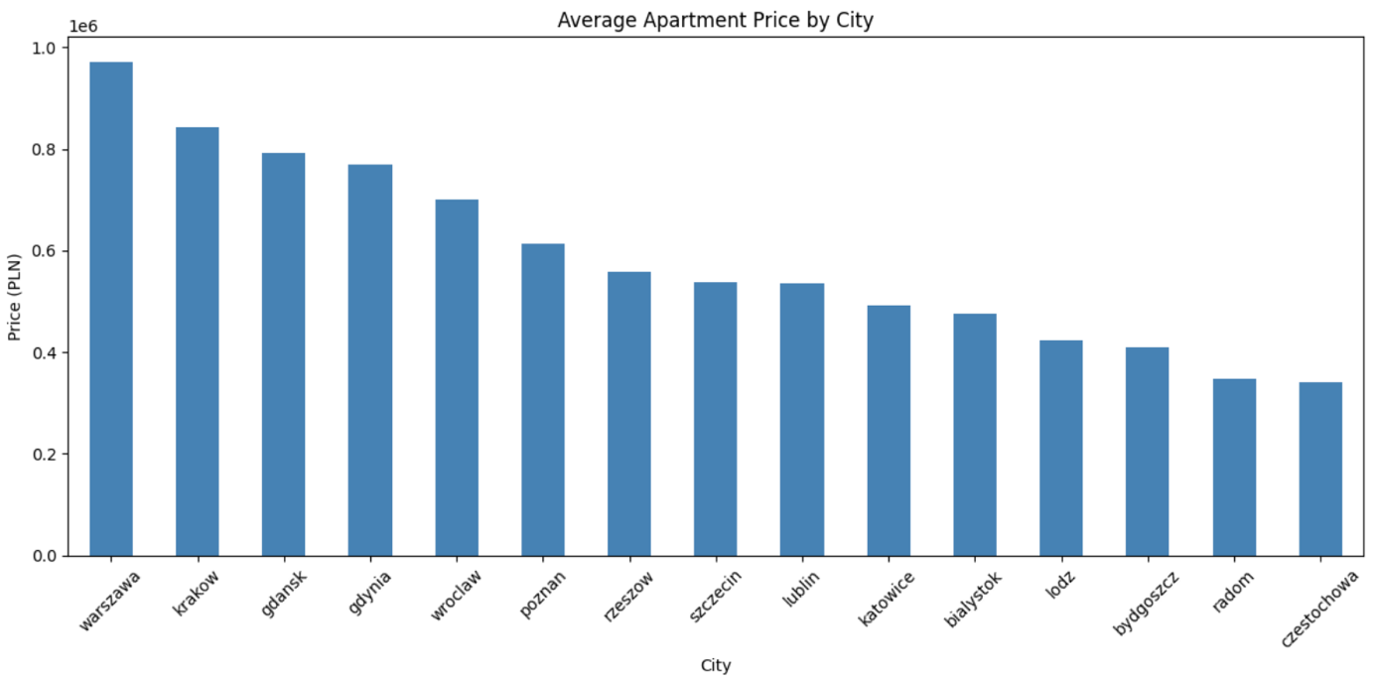

Multicollinearity table between each variable:

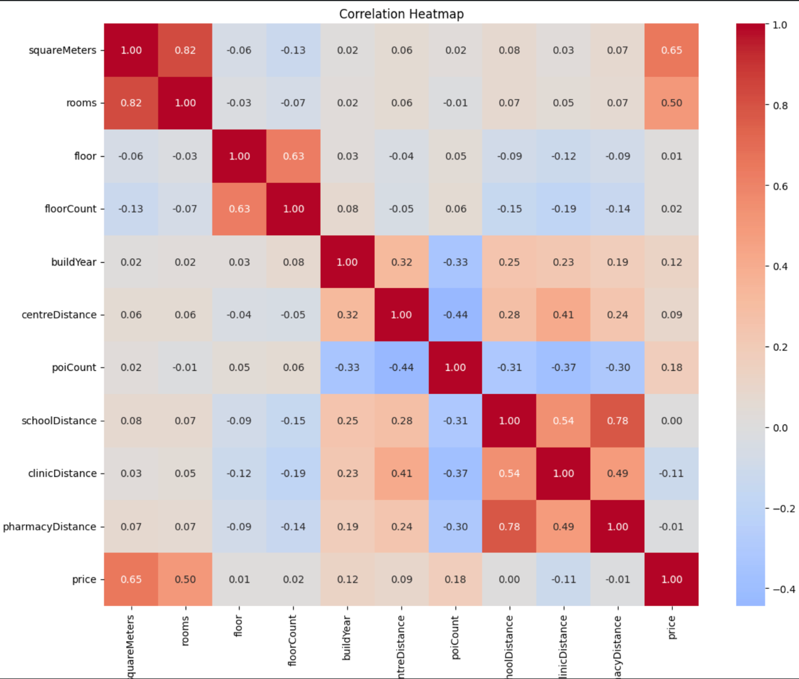
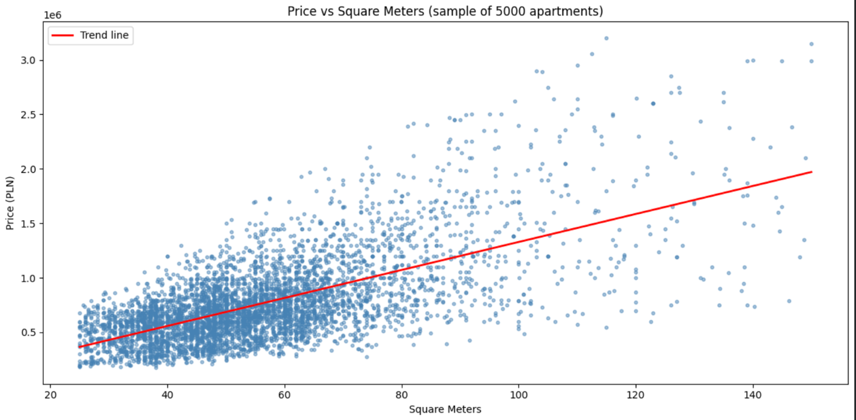

Graphs:
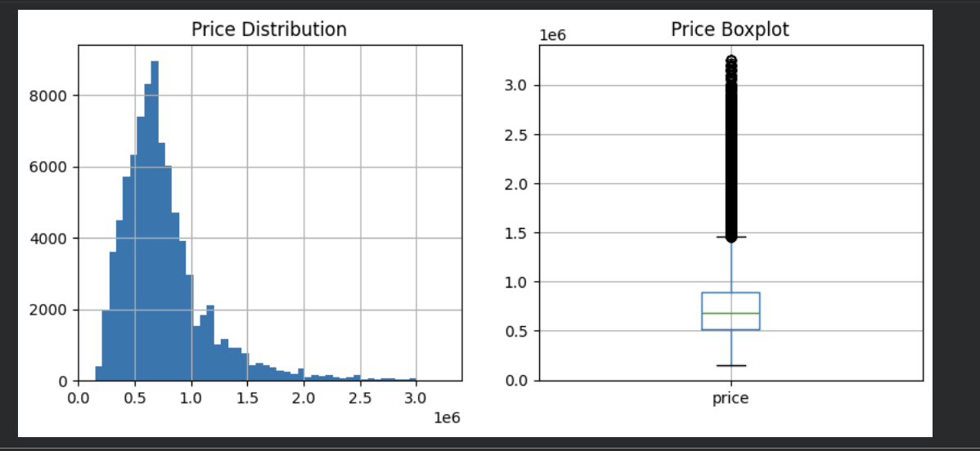
Some outliers are present (apartments very expensive, more than 1,4 million zloty).
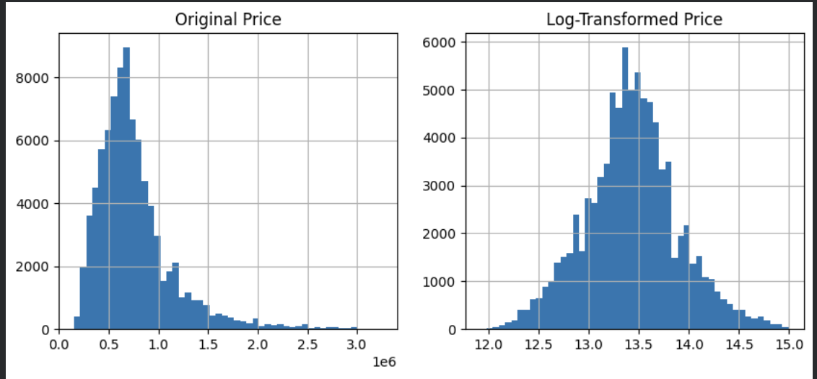

Log to transform the prices, which looks like a normal distribution.

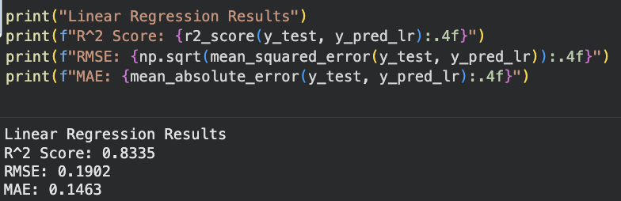
The linear regression shows that the model explains 83,35% of the variation for apartment prices.
RMSE and MAE are very similar so it means errors on prediction are consistent (same prediction got errors).
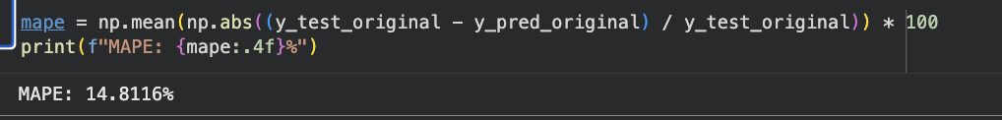
14,81% of the prediction are not on correct prices.
Overall best model for prediction in our case was Random Forest, with 10,03% percent of errors. So Random Forest model will be used for the rest of our work.

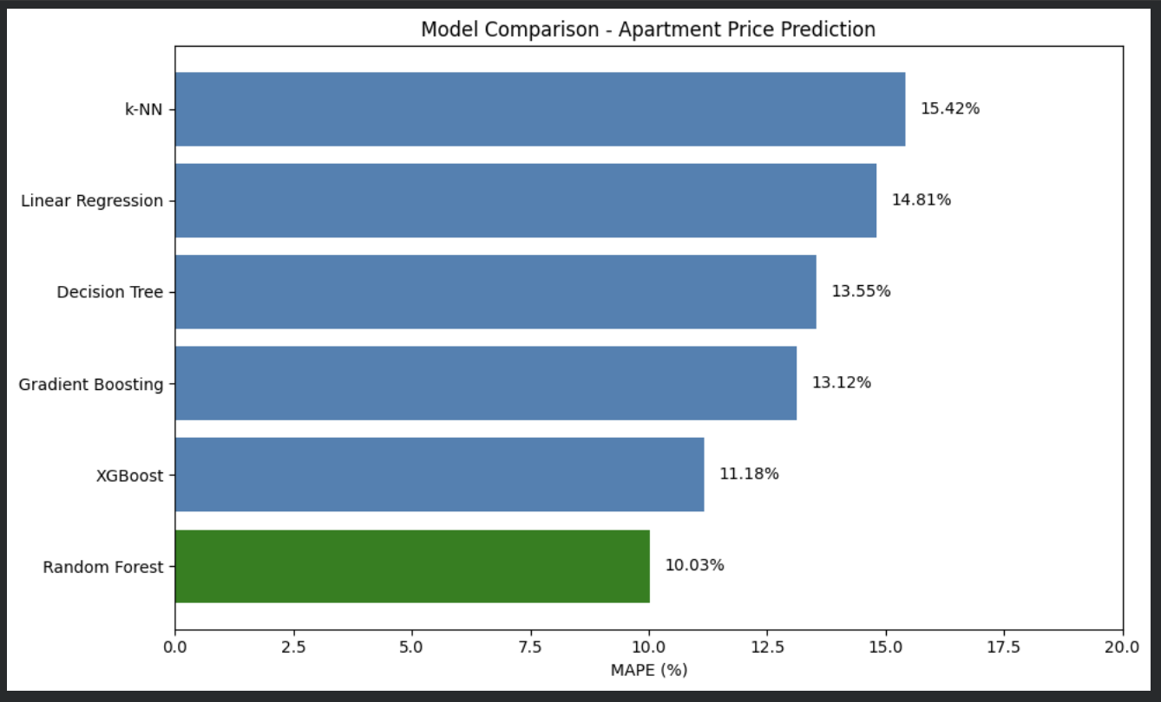

Random Forest permits us to see what the most important variables is to find the prince.

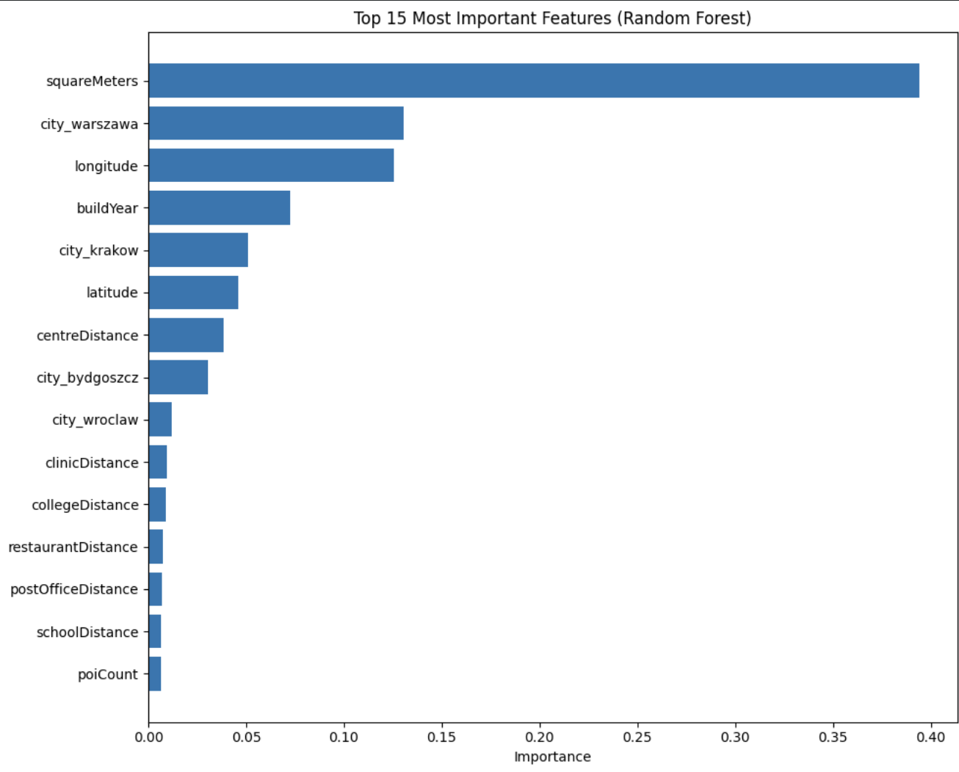

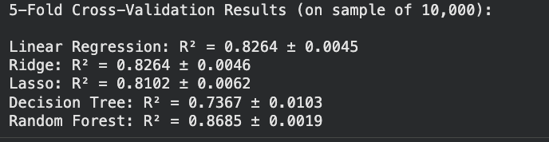
5fold cross validation confirms use that Random Forest model is the best for our analysis.

